

Strategy Based Maintenance Plan Creation
Document Control

Prepared by:
Version | Date | Name
1.0 | 01/30/2025 | SAI NISHITHA BOCHKAR
2.0

Reviewed by:
Version | Date | Name
1.0

Reference Documents

The following section describes relevant documentation:
Document Name | Description | Sharepoint Link
MAINTENANCE PLAN | STRATEGY BASED MAINTENANCE PLAN CREATION

Contents

1.Maintenance Strategy 4
1.1. DEFINITION: 4
1.2. TRANSACTION CODES: 4
1.3. STEPS TO CREATE A STRATEGY: 4
2.Strategy-Based Maintenance Plan 8
2.1. DEFINITION: 8
2.2. TRANSACTION-CODES: 8
2.3. STEPS TO CREATE MAINTENANCE PLAN: 8

1.Maintenance Strategy
1.1. DEFINITION:

A Maintenance Strategy in SAP PM is a predefined set of maintenance cycles that determine when specific maintenance tasks should be performed. It is the backbone of a Strategy-Based Maintenance Plan and allows for scheduling multiple maintenance activities at different time intervals within a single plan.

1.2. TRANSACTION CODES:

- IP11 - Define Maintenance Strategy
- IP01/IP42- Create Maintenance plan
- IP02- Change Maintenance Plan
- IP13 – Display Maintenance plan
1.3. STEPS TO CREATE A STRATEGY:

- Goto IP11 T-code in SAP GUI.
Maintenance strategy overview screen will be displayed.
Click on New Entries.

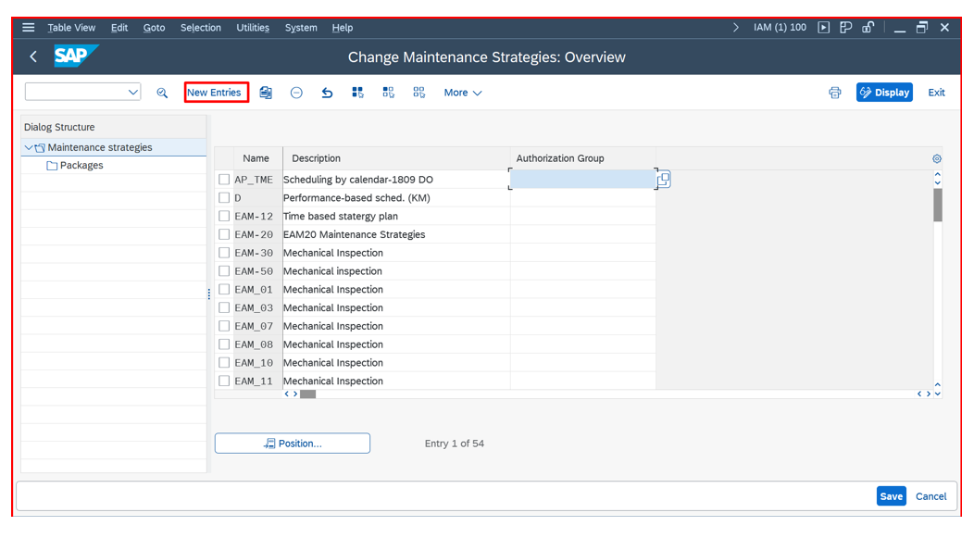
- Enter the strategy details such as name, description, scheduling indicator, strategy unit, call horizon, and shift factors.
Click on Save.

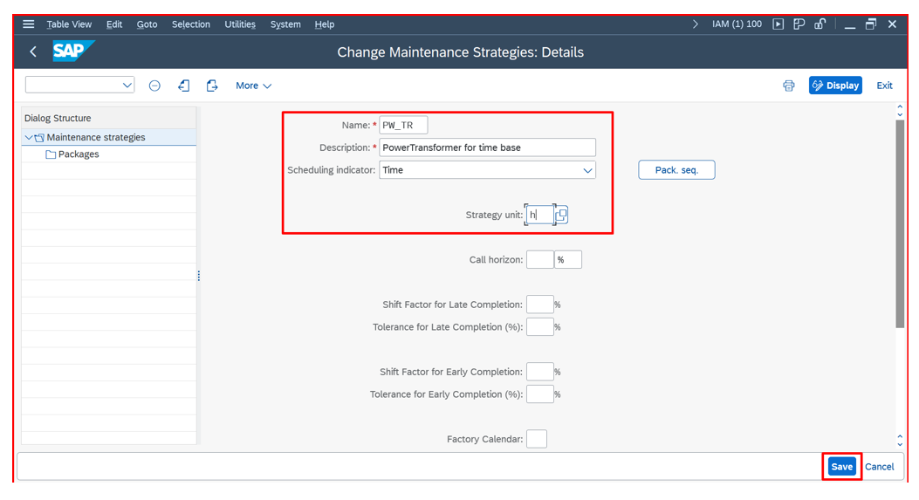

- Click on Position tab as shown below.

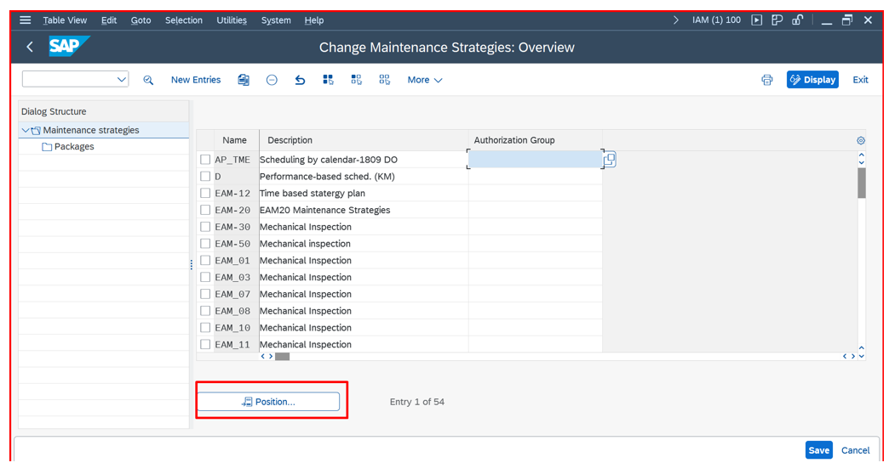
- Give the strategy name created and click on continue.

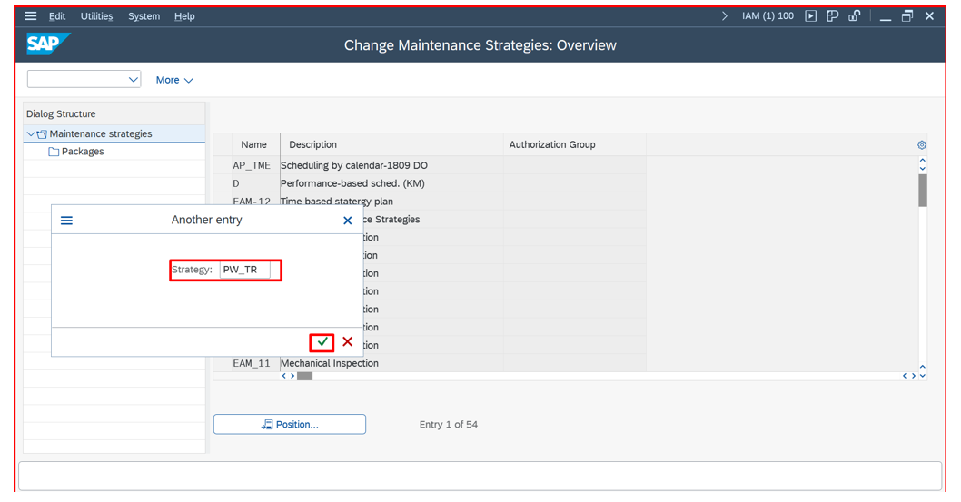

- Created maintenance strategy is displayed. Select and double-click on it.

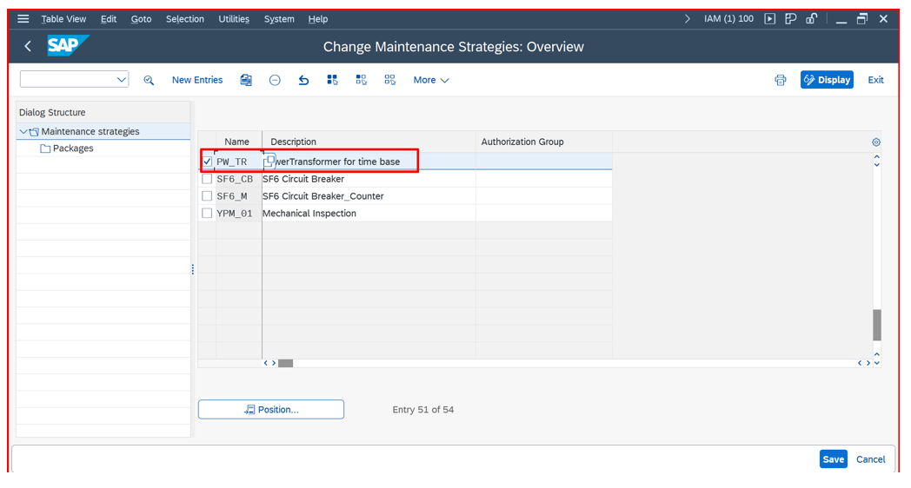

- Define the maintenance packages and Click on Packages.

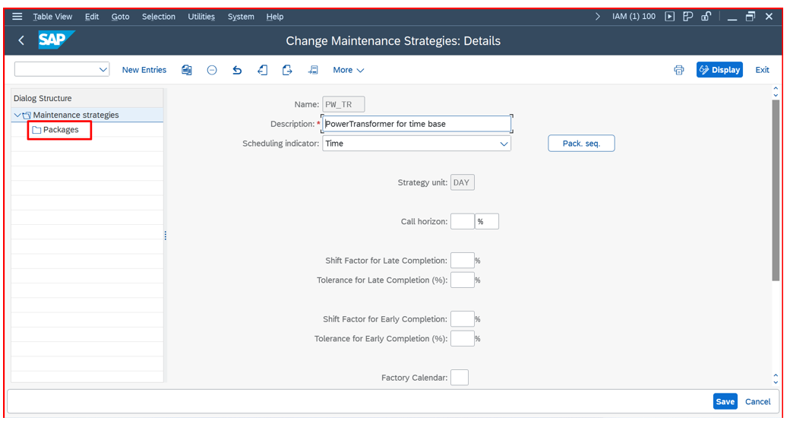

- Click on New entries.
Assign cycle lengths to each package.
Click on Save.

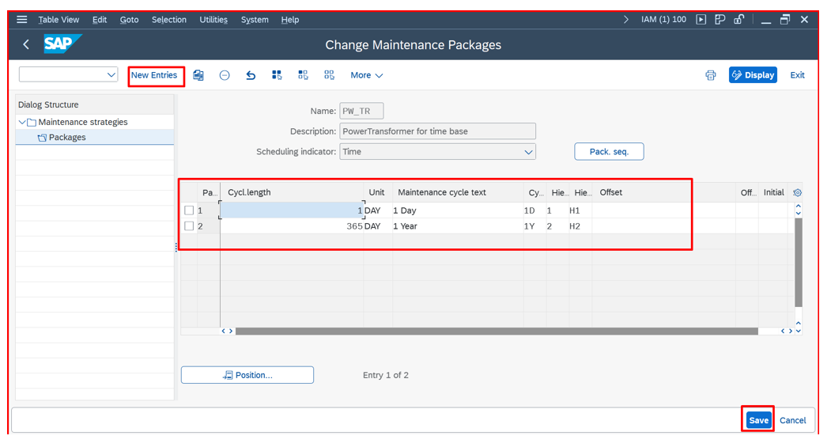

Maintenance Strategy is created.
2. Strategy-Based Maintenance Plan

2.1. Definition:

A Strategy-Based Maintenance Plan is used when different maintenance activities need to be scheduled at varying intervals for a piece of equipment, like a Power Transformer. It leverages a Maintenance Strategy that defines multiple cycles, ensuring proper preventive maintenance to enhance reliability and reduce downtime.

2.2. Transaction-Codes:

- IP01: Create Maintenance Plan
- IP02: Change Maintenance Plan
- IP03: Display Maintenance Plan
- IP10: Schedule Maintenance Plan
- IP19: Maintenance Scheduling Overview

2.3. Steps to Create Maintenance Plan

- Login to SAP GUI.

- SAP Menu Path:
SAP Menu > Logistics > Plant Maintenance > Preventive Maintenance > Maintenance planning > Maintenance plans> Create> Strategy plan

- Access the Maintenance plan Creation Screen.
Alternatively, Enter Transaction Code IP01 in SAP GUI.
Create Maintenance plan Initial screen will be displayed. Select Maintenance plan Category as Maintenance Order and mention strategy which is created.
Click enter.

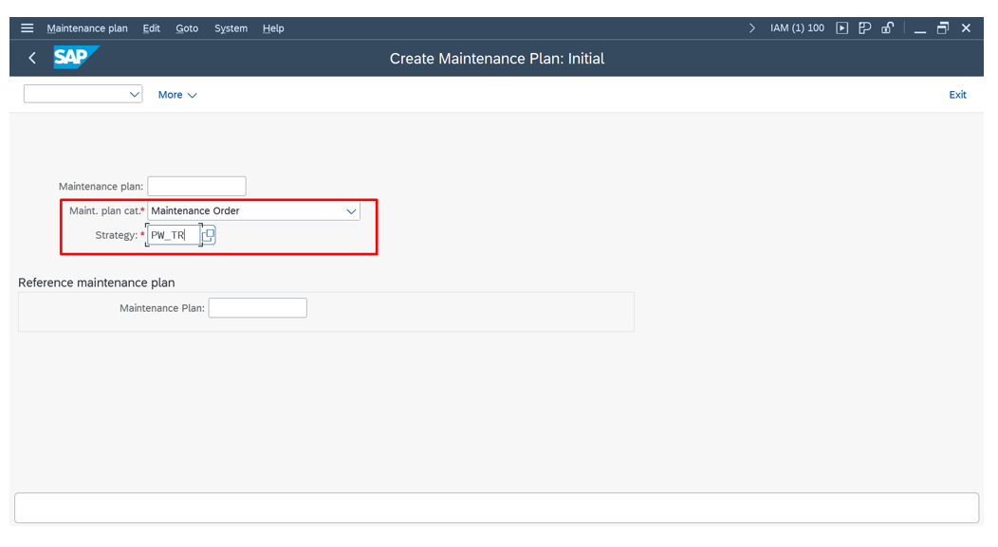

- Enter Maintenance plan and in maintenance plan cycle tab give the details.

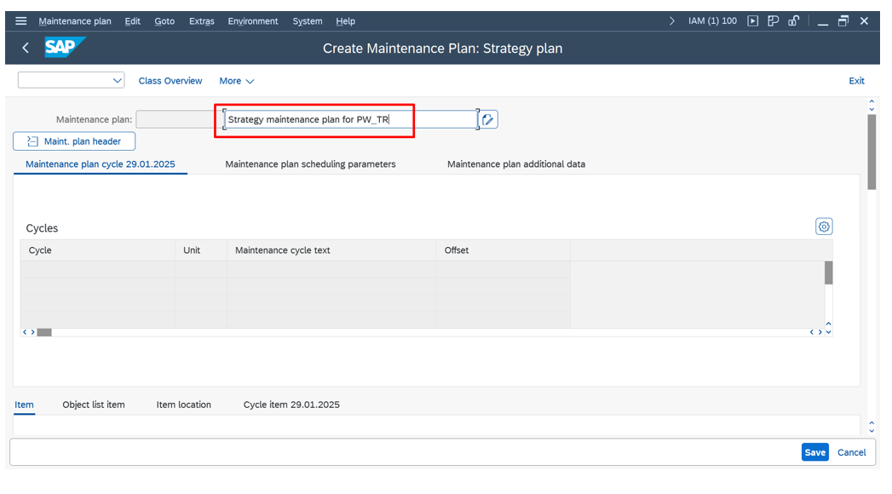

- In items tab, enter Reference object and Planning data details as required. Also enter Task list for strategy-based plan of power transformer.

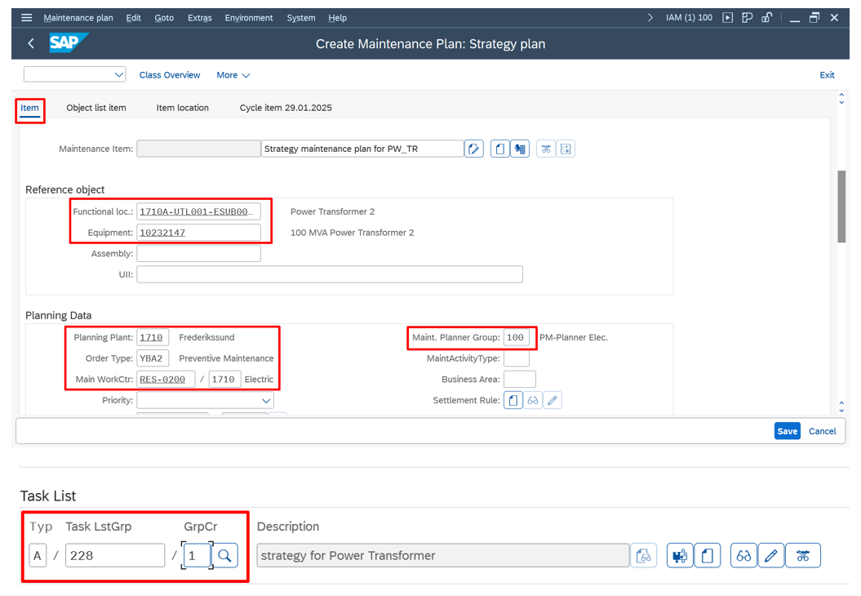

- In maintenance plan scheduling parameters tab, give the required details for date determination and call control parameter. For Scheduling-based maintenance plan, start of scheduling date should also be given.
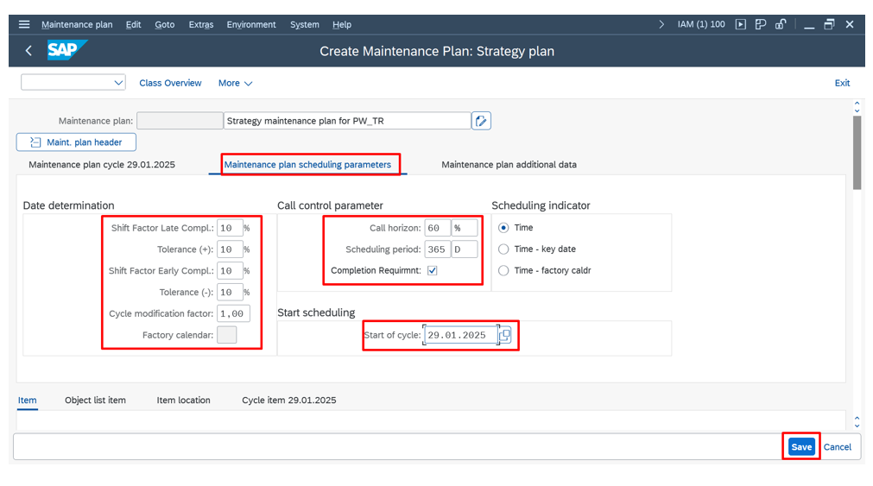

- Click on Save.

- Maintenance plan for strategy-based is created.

